Huawei GPON OLT Specifications summary:
Specification | MA5600T | MA5603T | MA5608T
Dimensions (H x W x D) | 447 mm x 490 mm x 275.8 mm | 263 mm x 442 mm x 283.2 mm | 88 mm x 442 mm x 233.5 mm
Operating Environment | –25°C to +55°C  5% RH to 95% RH | –40°C to +65°C  5% RH to 95% RH | –40°C to +65°C  5% RH to 95% RH
Power | –48V DC power input  Dual-power supply protection  Operating voltage range of –38.4V to –72V | –48V DC power input  Dual-power supply protection  Operating voltage range of –38.4V to –72V | –48V DC power input  Dual-power supply protection  Operating voltage range of –38.4V to –72V
Switching Capacity — Backplane Bus | 3.2 Tbit/s | 1.5 Tbit/s | 720 Gbit/s
Switching Capacity — Control Board | 1,920 Gbit/s | 960 Gbit/s | 512 Gbit/s
Access Capacity | 64 x 10G GPON  256 x GPON  768 x GE | 24 x 10G GPON  96 x GPON  288 x GE | 8 x 10G GPON  32 x GPON  96 x GE
Port Type | Upstream ports: 10 GE optical and GE optical/electrical ports  Service ports: GPON optical port, P2P FE optical port, P2P GE optical port, and Ethernet optical port
System Performance | Layer 2/Layer 3 line-rate forwarding  Static route, RIP, OSPF, and MPLS  Clock synchronization schemes: BITS, E1, STM-1, Ethernet clock synchronization, 1588v2, and 1PPS + ToD  Maximum split ratio of 1:256  Maximum logical distance between devices: 60 km

Huawei MA5600T OLT:
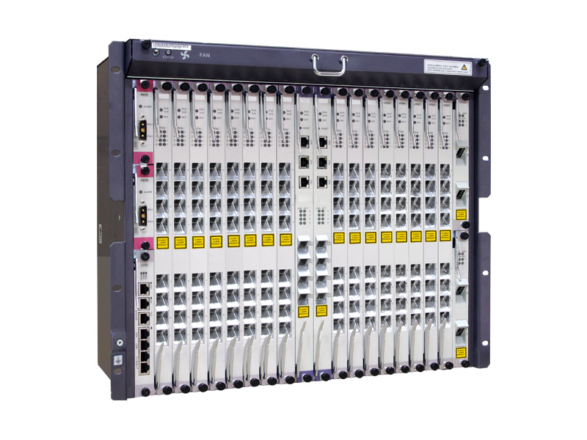

MA5600T Specifications:
Item | MA5600T(ETSI) |  | MA5600T(IEC)
Board configuration | 2 slots for control boards  16 slots for service boards  1 slot for the universal interface board  2 slots for upstream interface boards  2 slots for power interface boards. |  | 2 slots for control boards  14 slots for service boards  1 slot for the universal interface board  2 slots for upstream interface boards  2 slots for power interface boards.
Switching capacity of the backplane bus | 3.2 Tbit/s
Supported control board and its switching capacity | SCUN: 480 Gbit/s in active/standby mode or 960 Gbit/s in load-sharing mode  SCUH: 960 Gbit/s in active/standby mode or 1920 Gbit/s in load-sharing mode  SCUB: 48 Gbit/s  SCUF: 128 Gbit/s
System Layer 2 packet forwarding rate | SCUN: 480 Gbit/s in active/standby mode or 960 Gbit/s in load-sharing mode  SCUH: 960 Gbit/s in active/standby mode or 1920 Gbit/s in load-sharing mode  SCUB: 48 Gbit/s  SCUF: 128 Gbit/s
Switching/Forwarding delay | Short forwarding delay: The 100 Mbit/s Ethernet port sends the 64-byte Ethernet packets at a delay shorter than 20 μs.
BER in full load | BER of a port when the port transmits data in full load < 10 e-7
System reliability specifications | System: redundant configuration.  System availability for the typical configuration: > 99.999%  Mean time between failures (MTBF): about 45 years.  NOTE  Due to different network environments and a different board used by devices, the above-mentioned MTBF (45 years) of this is only for reference. The average repair time for field replaceable units (FRUs) is about 2 hours. The preceding values are only for reference. For details, contact the related Huawei engineers.
Maximum number of ADSL2+ ports in a subrack | 1024 | 896
Maximum number of VDSL2 ports in a subrack | 1024 | 896
Maximum number of EFM SHDSL ports in a subrack | 512 | 448
Maximum number of TDM SHDSL ports in a subrack | 256 | 224
Maximum number of POTS ports in a subrack | 1024 | 896
Maximum number of ISDN BRA ports in a subrack | 512 | 448
Maximum number of ISDN PRA ports in a subrack | 64 | 56
Maximum number of GPON ports in a subrack | 256 | -
Maximum number of 10G GPON ports in a subrack | 128 | -
Maximum number of EPON ports in a subrack | 256 | 224
Maximum number of 10G EPON ports in a subrack | 128 | 112
Maximum number of P2P FE ports in a subrack | 768
Maximum number of P2P GE ports in a subrack | 768 | -
Maximum number of upstream ports (GE ports in the GIU slot) in a subrack | 8
Maximum number of upstream ports (10GE ports in the GIU slot) in a subrack | 4
Maximum number of upstream ports (PON ports in the GIU slot) in a subrack | 2 (in the active/standby mode)
Maximum number of extended subracks connected to a master subrack | 32
Operating environment | Operating temperature (indoor cabinet):  1. A cabinet configured with a subrack: -25°C to +65°C  2. A cabinet configured with 2 subracks: -25°C to +55°C  Operating humidity: 5% RH to 95% RH  Atmospheric pressure: 61 kPa to106 kPa  Altitude: ≤ 4000 m
MA5600T Features:
Classification | Feature
Access features | - 10G GPON access  - GPON access  - P2P access  - ADSL/ADSL2/ADSL2+ access  - VDSL2 access (supporting vectoring)  - ATM SHDSL/EFM SHDSL access  - TDM SHDSL access
Multicast | - PIM-SSM  - IGMP snooping  - IGMP proxy  - Multicast VLAN management  - Multicast program management  - Multicast user management  - Multicast CAC  - VPLS multicast
Layer 3 features | - VLAN Layer 3 interface  - ARP  - ARP proxy  - DHCP relay  - DHCP option 60  - Static routing  - RIP dynamic routing  - OSPF dynamic routing  - IS-IS dynamic routing  - BGP dynamic routing  - DHCP proxy  - ECMP  - VRF  - VRRP snooping
IPv6 | - IPv6 basic feature  - IPv6 QoS  - IPv6 Layer 2 forwarding  - BGP4+  - *OSPF v3
Voice service | - VoIP  - SIP  - H.248  - ISDN BRA/PRA access  - FOIP  - MOIP  - POTS voice service  - Issuing voice configurations through OMCI  - R2 PBX access  - H.248/SIP dual upstream transmission
OAM features | - Remote operation and user management  - Version and data management  - Device exception management  - Service overload control  - ETH OAM(Y.1731)  - RING check  - ANCP  - *Intelligent site management  - *Centric Management for GE Remote Extended Subracks in FTTB or FTTC Scenarios  - *GE upstream commission outside of the site
Clock features | - BITS access clock synchronization  - Synchronous Ethernet clock  - System internal clock  - Network time synchronization  - Line recovered clock (E1/STM-1/SAToP)
Control board redundancy | - Load-balancing mode  - Active/Standby mode
MPLS | - Basic MPLS functions  - MPLS RSVP-TE  - MPLS OAM  - Graceful restart (GR) function of the LDP, RSVP-TE, and PW  - As a P device  - MPLS PW traffic label  - VPLS
Broadband Layer 2 features | - MAC address management  - MAC address learning  - VLAN attribute management  - Service stream processing  - Layer 2 forwarding policy  - Traffic classification  - VLAN switching policy  - Bridging
Layer 2 tunnel emulation technology | - TDM PWE3  - ATM PWE3  - ETH PWE3  - Terminating the SAToP service and transmitting the service upstream through the STM-1/E1 port  - Terminating the native TDM service and transmitting the service upstream through the E1/STM-1 port
QoS | - Priority processing  - Traffic management  - ACL policy  - Congestion management  - HQoS
Network protection features | - MSTP  - RRPP  - Smart link and monitor link  - Inter-board aggregation  - Ethernet link aggregation (through the LACP protocol)  - BFD  - STM-1 port protection switching  - Redundancy protection  - GPON Type C
Environment monitoring | - Monitoring parameters: temperature, humidity, water, smoke, MDF, and door status sensor  - Temperature control unit (TCU) management  - Battery online status monitoring and alarm reporting  - SMU power management
Security | - User security  - System security  - OAM security  - Line security
System energy conservation | - Energy conservation control  - Energy consumption monitoring

MA5600T Boards Descriptions:
Board Type |  | Board | Full Name | Function
Control board |  | H801SCUH | Super Control Unit Board | - System control and management unit  - Local and remote maintenance  - Active/standby switchover  - Load balancing  - Ethernet synchronization  - Built-in 2GB CF card  - GE/10GE/20GE channel to the service board  - Environmental monitoring parameters  - Supports the function of reading the temperature and the high-temperature alarm.  - Four SFP GE/10GE ports for upstream transmission or cascading
 |  | H801SCUN | super control unit board | - System control and management unit  - Local and remote maintenance  - Active/standby switchover  - Load sharing  - GE or 10GE channel to the service board  - Environmental monitoring parameters  - H801CKMC daughter board  - Four GE upstream optical ports with the SFP optical module
Upstream interface board |  | H801GICK | 2-port GE optical interface board | - Upstream transmission and cascading  - Two SFP GE optical/electrical ports (auto-adaptation)  - Ethernet clock synchronization
 |  | H801X2CS | 2-port 10GE upstream interface board | - Two 10GE upstream ports  - 10GE synchronous Ethernet
Universal interface board |  | H801CITB | combo interface transfer board | - Input and output of external alarms  - Two BITS inputs (this function requires the support of an H801BITSB daughter board)
Power interface board |  | H801PAIC | power board | - One -48 V power input  - Current filtering and transient high voltage protection for input power  - Under-voltage detection, input power detection (whether exists or not), and fault detection  - Alarm, board type signal, and presence signal reporting  - ALARM indicator
Service board | GPON interface board | H802GPBD | 8-port GPON OLT interface board | - Eight GPON SFP ports (one-fiber bi-directional port)  - A maximum of 128 ONTs for each GPON port  - Class B+ and class C+ optical modules  - Received signal strength indicator (RSSI) detection and controlled optical signal transmission of the optical module  - Temperature query and board power-off in case of a high temperature
 |  | H805GPBD | 8-port GPON OLT interface board | - Eight GPON SFP ports (one-fiber bi-directional port)  - A maximum of 128 ONTs for each GPON port  - Class B+ and class C+ optical modules  - Received signal strength indicator (RSSI) detection and controlled optical signal transmission of the optical module  - ONU-based shaping  - Temperature query and board power-off in case of a high temperature
 | Combo board | H85BCVME | 48-port VDSL2&POTS combo board | - 48-channel VDSL2 and POTS access service  - Built-in splitter  - Configurable impedance for the POTS port; working with the built-in splitter to support 600-ohm or 900-ohm impedance  - Port protection  - Polarity-reversal accounting, and pulse accounting  - Balanced ringing (unbalanced ringing is not supported)  - POTS metallic loop test (MELT)  - Single-ended loop test (SELT) and dual-ended loop test (DELT)  - ITU-T G.711, ITU-T G.723.1, and ITU-T G.729 codec  - ITU-T T.30 fax and ITU-T T.38 fax  - G.992.1 Annex A/B, G.992.2 Annex A, G.992.3 Annex A/B/L(RE-ADSL2)/M/J, and G.992.5 Annex A/B/M/J  - VDSL2 8a, 8b, 8c, 8d, 12a, 12b, and 17a profiles  - G.INP physical layer retransmission  - VLAN based user bridging
 | SPU board | H801SPUB | service processing unit board | - 10 Gbit/s (unidirectional 10 Gbit/s, bidirectional 5 Gbit/s) MPLS switching capability  - One 10GE attachment unit interface (XAUI) to each control board  - Active/standby switchover of the control boards
 | Voice board | H802EDTB | 16-port T1 service board | - 16 channels of E1/T1 access services  - Independent upstream and downstream transmission of each channel of E1/T1 clock signals  - Configuration of the Tx clock source of an E1/T1 port  - Specifying the line clock of an E1/T1 port as the system clock source  - Timeslot binding  - TDM PWE3 service  - CPE mode
 | P2P interface board | H802OPGD | 48-port GE/FE optical interface board | - 48 (CSFP) or 24 (SFP) channels of GE/FE P2P optical access services  - Cascading and aggregation of DSLAMs or MxUs  - Synchronous Ethernet clock issuing  - Two-channel one-fiber bi-directional CSFP, one-channel two-fiber bi-directional SFP, and one-channel one-fiber bi-directional SFP optical modules
 |  | H802OPGE | 48-port GE/FE optical interface board | - 48 (CSFP) or 24 (SFP) channels of GE/FE P2P optical access services  - Cascading and aggregation of DSLAMs or MxUs  - Synchronous Ethernet clock issuing  - Two-channel one-fiber bi-directional CSFP, one-channel two-fiber bi-directional SFP, and one-channel one-fiber bi-directional SFP optical modules  - 1588v2  - Jumbo frame
 | Ethernet service access board | H801ETHB | Ethernet service access board | - Ethernet upstream transmission  - Ethernet cascading  - Eight SFP GE optical modules  - Intra-board aggregation

