Huawei MA5608T OLT:
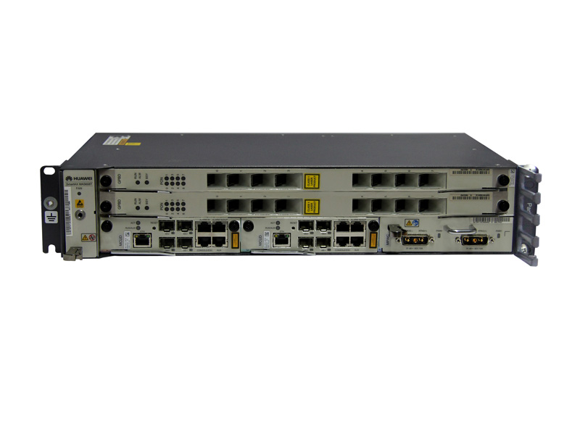
MA5608T Control Boards:
H801MCUD1 board
The H801MCUD1 board is a Mini Control Unit Board. It is the core of the system control and service switching and aggregation. The H801MCUD1 board can also function as the management and control core of the integrated network management system (NMS). It communicates with service boards about the key management and control information through the master/slave serial port and inband GE/10GE channel. In this manner, the H801MCUD1
board configures, manages, and controls the device, and also implements the simple route protocol functions.
The H801MCUD1 board supports the following functions:
- System control and management unit
- Local and remote maintenance l Active/standby switchover l Load sharing
- Synchronous Ethernet
- GE or 10GE channel to the service board
- Environmental monitoring parameters
- Seven inputs of alarm digital parameters and one output of alarm digital parameters
- Temperature reading and high-temperature alarm
- Fan tray monitoring and management
- Two SFP+ 10GE ports and two SFP GE ports for upstream transmission or cascading
- One input of BITS clock signals and one input of BITS clock signals
- One input of 1PPS+TOD time signals and one output of 1PPS+TOD time signals
- Stratum-3 clock
MA5608T Service Boards:
H805GPBD Board
H805GPBD is a 8-port GPON OLT Interface Board. It works with the optical network terminal (ONT) to provide GPON access service.
The H805GPBD board supports the following functions:
- Eight GPON SFP ports;
- A maximum of 1:128 split ratio;
- Class B+ and Class C+ optical modules;
- Received signal strength indicator (RSSI) detection and controlled optical signal transmission of the optical module;
- ONU-based shaping;
- Optical performance monitor (OPM);
- Automatic power shutdown in case of a high temperature.
MA5608T Power Boards:
H801MPWC Board
The H801MPWC board is a power board with dual DC power inputs. The H801MPWC board leads in the -48 V DC power to the device.
The H801MPWC board supports the following functions:
- Two –48 V DC inputs
- Filtering and current-limiting for the power input port
- Detection of input under voltage, power supply availability, and power supply faults
- Reporting of the protection alarm together with board ready status
- Indication of power status
MA5608T Features:
SmartAX MA5608T is the global first all-in-one access platform which can provide DSL and optical integrated access. It can provide high density ADSL2+, VDSL2, POTS, ISDN, PON and Ethernet fiber P2P access, triple-play service, and TDM/ATM/Ethernet leased line services for business customers.
The MA5608T can also offer mobile backhaul with high reliability and high precision clock, and high density 2*GE/10GE interfaces for cascading remote access equipment’s. MA5608T helps to simplify network architecture, to enable seamless migration in FTTx network and lower TCO essentially.
Any Access
Support multiple access methods, VDSL2/ADSL2+/G.SHDSL/POTS/ISDN/ PON/Ethernet P2P;
Support multiple scenarios: FTTC / FTTB / FTTH / FTTO / FTTM.
Any Service
Large capacity IPTV service provision, 8K multicast users and 4K multicast channels;
H-QoS support 3-level QoS (Different ISP/service/user) guaranteeing OLT wholesale;
Traditional E1 service access, NATIVE TDM or CESoP for traditional E1 service of enterprise and mobile backhaul.
Boards supported by the MA5608T:
Board Type |  | Board | Full Name | Function
Control board |  | H801MCUD | Mini Control Unit Board | - System control and management unit  - Local and remote maintenance  - Active/standby switchover  - Load sharing  - Synchronization with the Ethernet clock  - GE or 10GE channel to the service board  - Environmental monitoring parameters  - Seven alarm digital inputs (DIs) and one alarm digital output (DO)  - Temperature reading and high temperature alarming  - Monitoring and management of the fan tray  Four SFP GE ports for upstream transmission or cascading
 |  | H801MCUD1 | Mini Control Unit Board | - System control and management unit  - Local and remote maintenance  - Active/standby switchover  - Load sharing  - Synchronous Ethernet  - GE or 10GE channel to the service board  - Environmental monitoring parameters  - Seven inputs of alarm digital parameters and one output of alarm digital parameters  - Temperature reading and high-temperature alarm  - Fan tray monitoring and management  - Two SFP+ 10GE ports and two SFP GE ports for upstream transmission or cascading  - One input of BITS clock signals and one output of BITS clock signals  - One input of 1PPS+TOD time signals and one output of 1PPS+TOD time signals  Stratum-3 clock
Power interface board |  | H801MPWC | Double DC power board | - Two -48 V DC inputs  - Filtering and current-limiting for the power input port  - Detection of input under voltage, power supply availability, and power supply faults  - Reporting of the protection alarm together with board ready status  Indication of power status
 |  | H801MPWD | AC power board | - Input AC voltage: -100 V to -240 V  - Input AC frequency: 50 Hz to 60 Hz  - Single-phase three-wire AC power input  - Battery port, a 3V3 terminal socket, supporting DC input power  - Lead-acid battery input, reverse polarity protection, and fuse protection  - Output DC power voltage: -48 V (adjustable from -42 V to -57.6 V)  - Rated output power: 400 W  - Alarm monitoring  - Enabling and disabling of the rectifier module; equalized and float charging for the rectifier module  Battery low voltage disconnection; charge and discharge management of storage batteries
Service board | GPON interface board | H805GPBD | 8-port GPON OLT interface board | - Eight GPON SFP ports (one-fiber bi-directional port)  - A maximum of 128 ONTs for each GPON port  - Class B+ and class C+ optical modules  - Received signal strength indicator (RSSI) detection and controlled optical signal transmission of the optical module  - ONU-based shaping  Temperature query and board power-off in case of a high temperature
 |  | H802GPFD | 16-port GPON OLT Interface Board | - Sixteen GPON SFP ports  - A maximum of 1:128 split ratio  - Class B+ and Class C+ optical modules  - Received signal strength indicator (RSSI) detection and controlled optical signal transmission of the optical module  - ONU-based queue shaping  - Temperature query and high temperature alarm  Automatic power shutdown in case of a high temperature
 | SPU board | H801SPUB | service processing unit board | - 10 Gbit/s (unidirectional 10 Gbit/s, bidirectional 5 Gbit/s) MPLS switching capability  - One 10GE attachment unit interface (XAUI) to each control board  Active/standby switchover of the control boards
 | Voice board | H802EDTB | 16-port T1 service board | - 16 channels of E1/T1 access services  - Independent upstream and downstream transmission of each channel of E1/T1 clock signals  - Configuration of the Tx clock source of an E1/T1 port  - Specifying the line clock of an E1/T1 port as the system clock source  - Timeslot binding  - TDM PWE3 service  CPE mode
 | P2P interface board | H802OPGD | 48-port GE/FE optical interface board | - 48 (CSFP) or 24 (SFP) channels of GE/FE P2P optical access services  - Cascading and aggregation of DSLAMs or MxUs  - Synchronous Ethernet clock issuing  Two-channel one-fiber bi-directional CSFP, one-channel two-fiber bi-directional SFP, and one-channel one-fiber bi-directional SFP optical modules
 | Ethernet service access board | H801ETHB | Ethernet service access board | - Ethernet upstream transmission  - Ethernet cascading  - Eight SFP GE optical modules  Intra-board aggregation

MA5600T series OLT specification:
